You were born with the ability to think and reason.
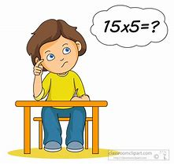

Your ability to think and reason makes it possible for you to make decisions and…

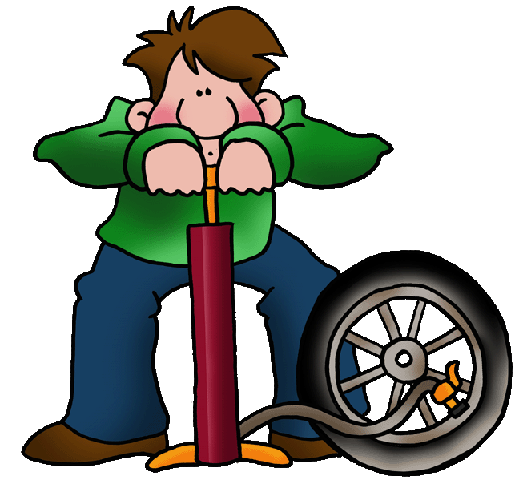
…solve problems.
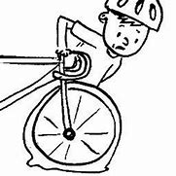

When you choose which cereal you want for breakfast, you make a decision.

When you choose what you are going to wear, you make a decision.
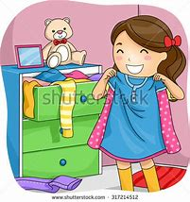

When you choose what you are going to do, you make a decision.

CHOOSE
I can choose. I can choose.
I can choose to win or lose.
I can smile or I can frown.
I can go on up or down.
I can smile and just say, “Hi”.
Or I can simply walk on by.
I can choose to cry and pout.
Or I can choose to laugh it out.
I can choose to rage and roar.
Or I can choose to reason more.
It’s up to me
Just how I’ll be…because…
I’m in charge of
the ‘CHOOSE’ in me!

